Check out the demo code for week 3 that is available in the Assignment module of the blackboard.

**Task 1:**

The discount amount is required to have two decimal places. Run the application and enter subtotal value 250; take a screenshot of it and paste it here.

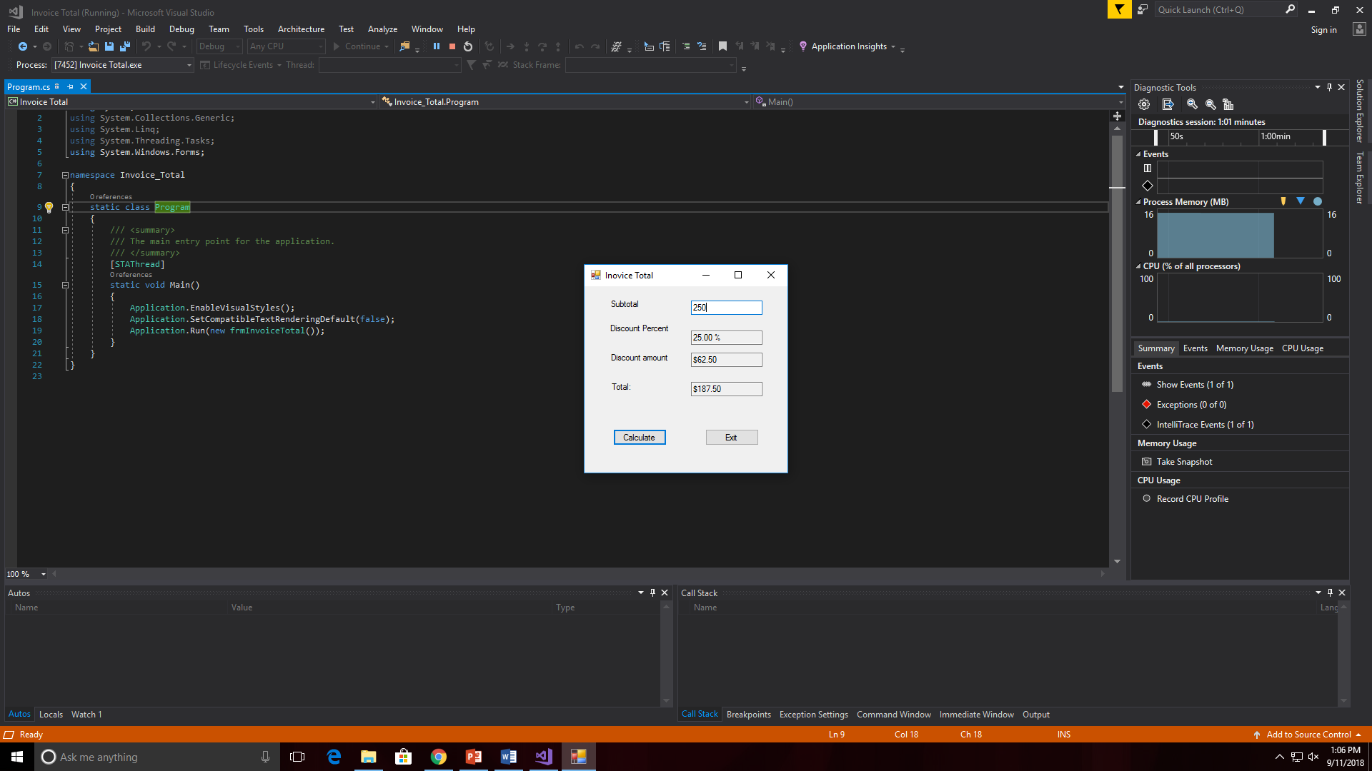

**Task 2:**

Change the discount percentage to 30% and the discount amount is required to have one decimal place. Run the application and enter subtotal value 250; take a screenshot of it and paste it here.

